Cafe evaluation survey

General

 | Survey name | Cafe evaluation survey
 | Author | Tomáš Pelán
 | Language | English
 | Survey URL | http://www.survio.com/survey/d/H1M7Q9R4Y1R1U6P1J
 | First response  Last response | 10/02/2014  11/20/2014
 | Duration | 50 days

Survey visits

28 | 21 | 0 | 7 | 75%
Total visits | Total completed | Total unfinished | Displayed only | Overall completion rate
Visit History (10/02/2014 - 11/20/2014)
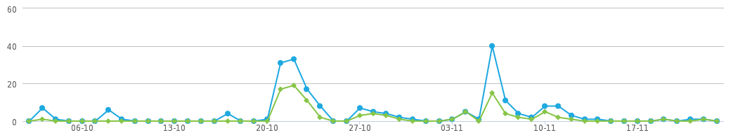
 | Total visits (28) |  | Total completed (21)

Total Hits | Visit Sources | Average Time of Completion
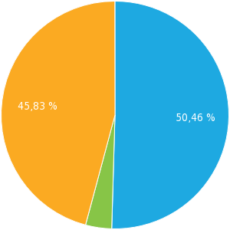 | 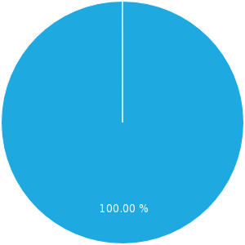 | 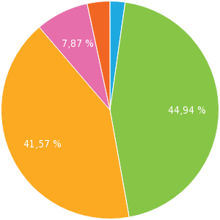
Displayed only (25.00%)  Unfinished (0.00%)  Completed (75.00%) | Direct link (100.00%) | 2-5 min. (2.25%)  5-10 min. (44.94%)  10-30 min. (41.57%)  30-60 min. (7.87%)  >60 min. (3.37%)

Results
How often do you visit cafes?
Single choice, answers 21x, unanswered 0x
Answer | Answers | Ratio
Daily | 2 | 9.52%
Several times a week | 6 | 28.57%
Once a month | 7 | 33.33%
Several times a month | 1 | 4.76%
Once a year | 3 | 14.29%
Several times a year | 2 | 9.52%
Never | 0 | 0.00%
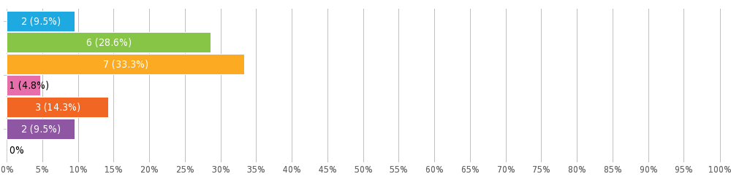
How would you rate as a customer the staff at our cafe?
Matrix of single choices, answers 21x, unanswered 0x
 | 1 | 2 | 3 | 4 | 5
A member of staff noticed me and served me immediately | 15 (71.43%) | 5 (23.81%) | 0 | 0 | 1 (4.76%)
The staff were helpful and pleasant | 6 (28.57%) | 9 (42.86%) | 5 (23.81%) | 1 (4.76%) | 0
The staff didn't create any tension | 4 (19.05%) | 6 (28.57%) | 9 (42.86%) | 1 (4.76%) | 1 (4.76%)
The service i was provided was quick | 2 (9.52%) | 5 (23.81%) | 9 (42.86%) | 5 (23.81%) | 0
The staff met all my needs quickly and to my satisfaction | 1 (4.76%) | 6 (28.57%) | 7 (33.33%) | 6 (28.57%) | 1 (4.76%)
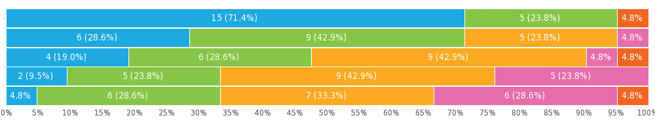
How likely is it you would recommend us to a friend?
Net Promoter Score®, answers 7x, unanswered 14x
0 | 1 | 2 | 3 | 4 | 5 | 6 | 7 | 8 | 9 | 10
Detractors (0 - 6) |  |  |  |  |  |  | Passive (7 - 8) |  | Promoters (9 - 10)
0.00% | 0.00% | 0.00% | 0.00% | 0.00% | 0.00% | 1 (14.29%) | 2 (28.57%) | 1 (14.29%) | 3 (42.86%) | 0.00%
Detractors 1 (14%) Passive 3 (43%) Promoters 3 (43%)  NPS = Promoters (43%) – Detractors (14%) | +29%  Net Promoter Score®

To what extent do you agree with the following statements referring to your experience in our cafe?
Matrix of single choices, answers 21x, unanswered 0x
 | I strongly agree | I agree | I disagree | I strongly disagree
The quality and speed of service was excellent | 2 (9.52%) | 8 (38.10%) | 10 (47.62%) | 1 (4.76%)
The food served was of a high quality and tasted good | 2 (9.52%) | 11 (52.38%) | 7 (33.33%) | 1 (4.76%)
The price list was affordable | 2 (9.52%) | 5 (23.81%) | 10 (47.62%) | 4 (19.05%)
The cafe environment was comfortable and soothing | 3 (14.29%) | 7 (33.33%) | 10 (47.62%) | 1 (4.76%)
The cafe menu was adequate for my needs | 2 (9.52%) | 6 (28.57%) | 11 (52.38%) | 2 (9.52%)
An Internet connection was available and fast enough for my needs. | 2 (9.52%) | 9 (42.86%) | 9 (42.86%) | 1 (4.76%)
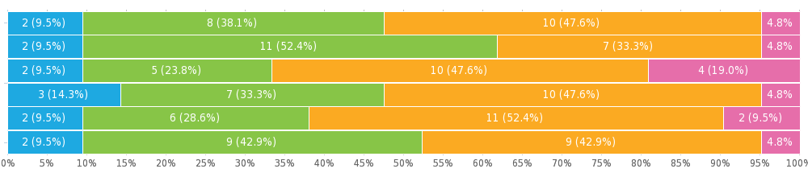

How would you rate our coffee?
Star Rating, answers 21x, unanswered 0x
Number of stars 4.05/5
Answer | Answers | Ratio
5/5 | 6 | 28.57%
4/5 | 11 | 52.38%
3/5 | 3 | 14.29%
2/5 | 1 | 4.76%
1/5 | 0 | 0.00%
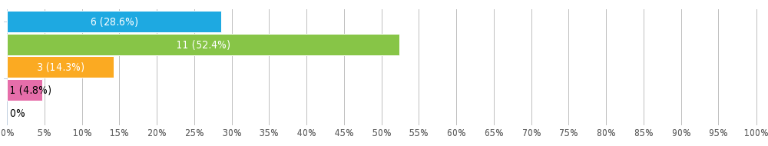
Would you recommend our cafe to a friend or colleague?
Single choice, answers 21x, unanswered 0x
Answer | Answers | Ratio
Yes | 18 | 85.71%
No | 3 | 14.29%
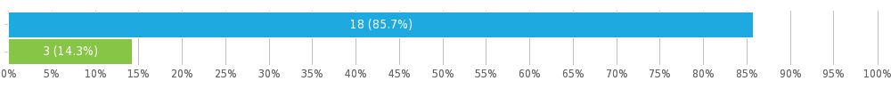
Please confirm your gender:
Single choice, answers 21x, unanswered 0x
Answer | Answers | Ratio
Male | 15 | 71.43%
Female | 6 | 28.57%
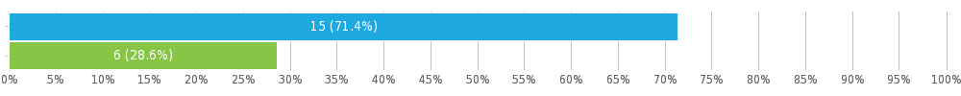
To which of the following age groups do you belong?
Single choice, answers 21x, unanswered 0x
Answer | Answers | Ratio
Under 20 | 3 | 14.29%
20 - 30 | 9 | 42.86%
30 - 40 | 4 | 19.05%
40 - 50 | 3 | 14.29%
50 - 60 | 1 | 4.76%
Over 60 | 1 | 4.76%
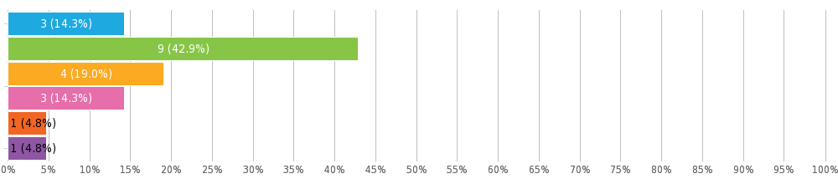

Survey settings

 | Questions per page | Multiple
 | Allow multiple submissions?
 | Allow return to previous questions?
 | Display question numbers?
 | Randomise question order?
 | Show progress bar?
 | Receive response notifications by email?
 | Password protection?
 | IP restriction?

Appendix: Survey
Cafe evaluation survey
Hello,
Please take a few minutes of your time to fill in the following survey.
How often do you visit cafes?
Daily
Several times a week
Once a month
Several times a month
Once a year
Several times a year
Never
How would you rate as a customer the staff at our cafe?
Question instructions: Please mark: 1 - Excellent, 5 - Worst
 | 1 | 2 | 3 | 4 | 5
A member of staff noticed me and served me immediately
The staff were helpful and pleasant
The staff didn't create any tension
The service i was provided was quick
The staff met all my needs quickly and to my satisfaction
How likely is it you would recommend us to a friend?
0 | 1 | 2 | 3 | 4 | 5 | 6 | 7 | 8 | 9 | 10
To what extent do you agree with the following statements referring to your experience in our cafe?
 | I strongly agree | I agree | I disagree | I strongly disagree
The quality and speed of service was excellent
The food served was of a high quality and tasted good
The price list was affordable
The cafe environment was comfortable and soothing
The cafe menu was adequate for my needs
An Internet connection was available and fast enough for my needs.
How would you rate our coffee?
/ 5
Would you recommend our cafe to a friend or colleague?
Yes
No
Please confirm your gender:
Male
Female
To which of the following age groups do you belong?
Under 20
20 - 30
30 - 40
40 - 50
50 - 60
Over 60

